**1.0 Intention**

The intention I created this website is to raise the awareness in knowing the importance of being discipline in life. This is the lesson I learned from my past life. I am a procrastinator and I’m always feeling lost, so I knew the impact of not having self-awareness in one’s life.

Therefore, I decided to gather some of the best online education resources from the internet in this website, to letting people aware the importance of being self-discipline in life. Those resources encourage people to have a more organized life and a better future.

The website are designed to be user-friendly, there are navigation bars in every main page and the website logo are display flex in a row. There are also sign up function, login function, and contact form function coded by javascript. Despite that, internal navigations are also provided in the home page and roadmap page. Moreover, all the external navigations are coded with an attributes target=”_blank”, the browser will open a new tab when user press the anchor links, this provide better experience. Iframe embedded videos are used in home page to provide better UI experience.

**2.0 Implementation Details**

**Sign Up Function**

**Succefully signed up**

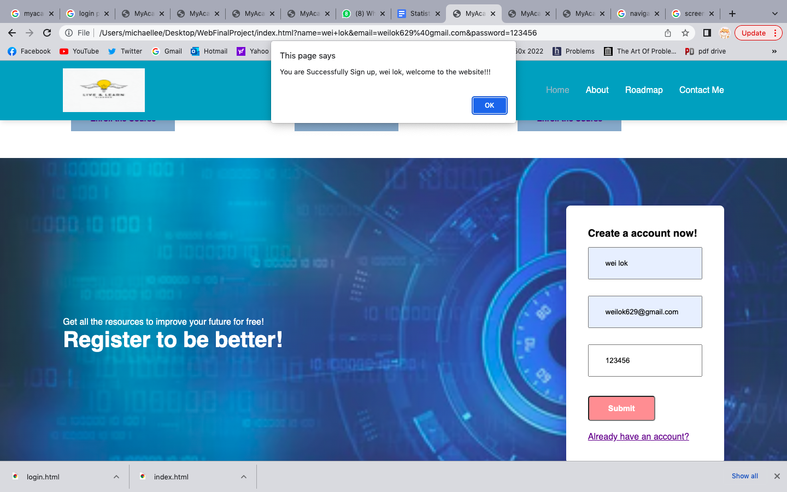

**Failed to sign up (not providing correct email format)**

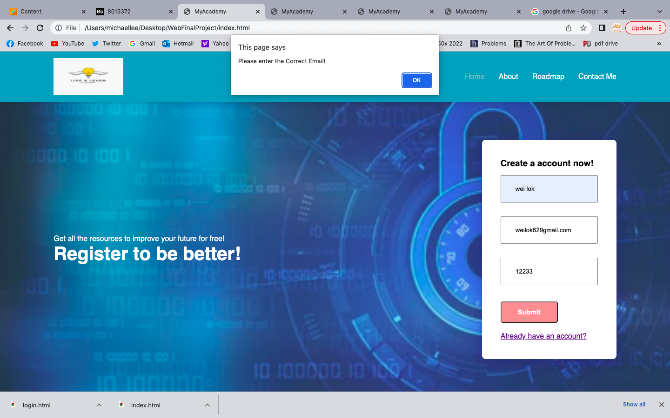

A simple sign up function is provided in the sign up section. The sign up form will let the user to enter username, email address, and password. If user enters invalid email address, error message will be alerted. Despite that, any username or password can be accepted.

**Login Function**

The login page is equipped with a login function, it checks the format of email address, there must be ‘@’ and ‘.’ in an email address.

**Succefully login**

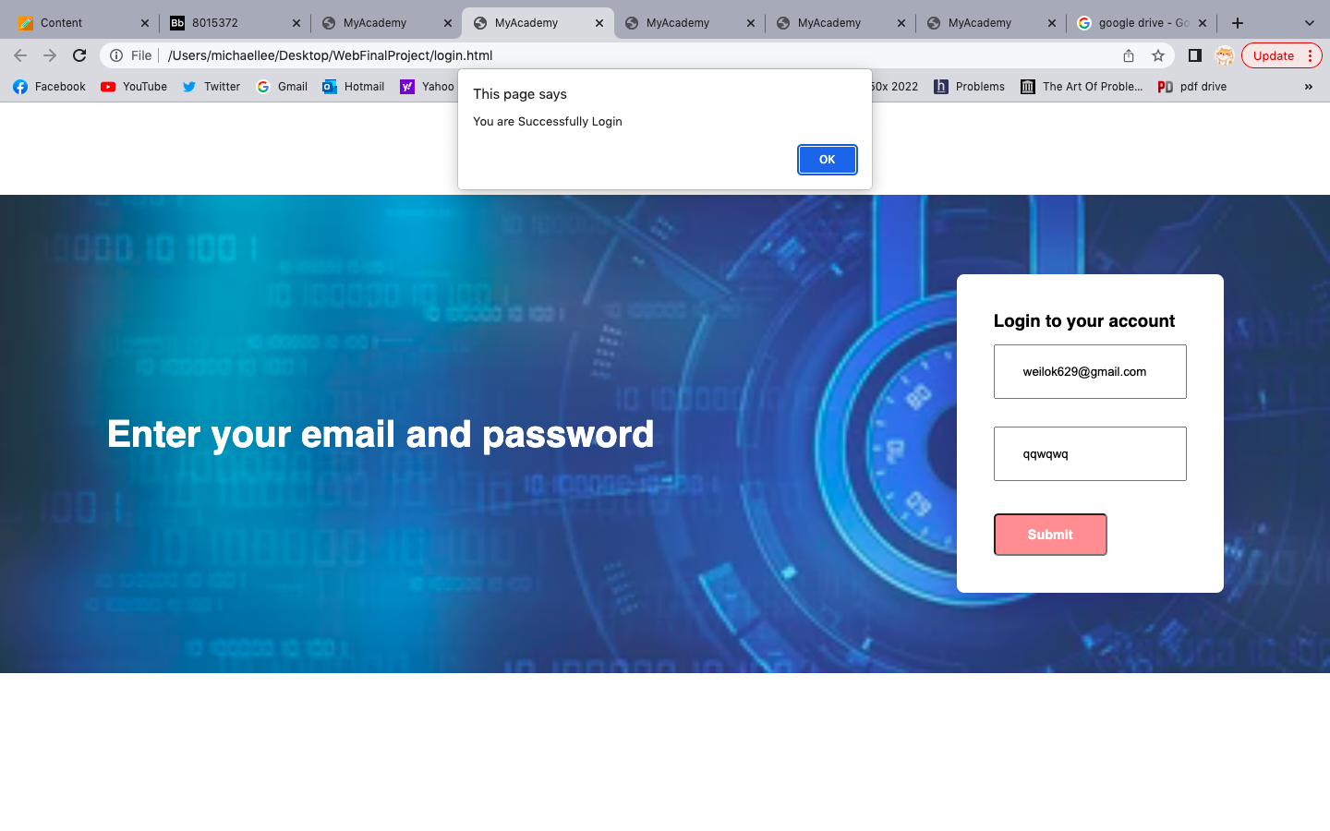

**Failed to login**

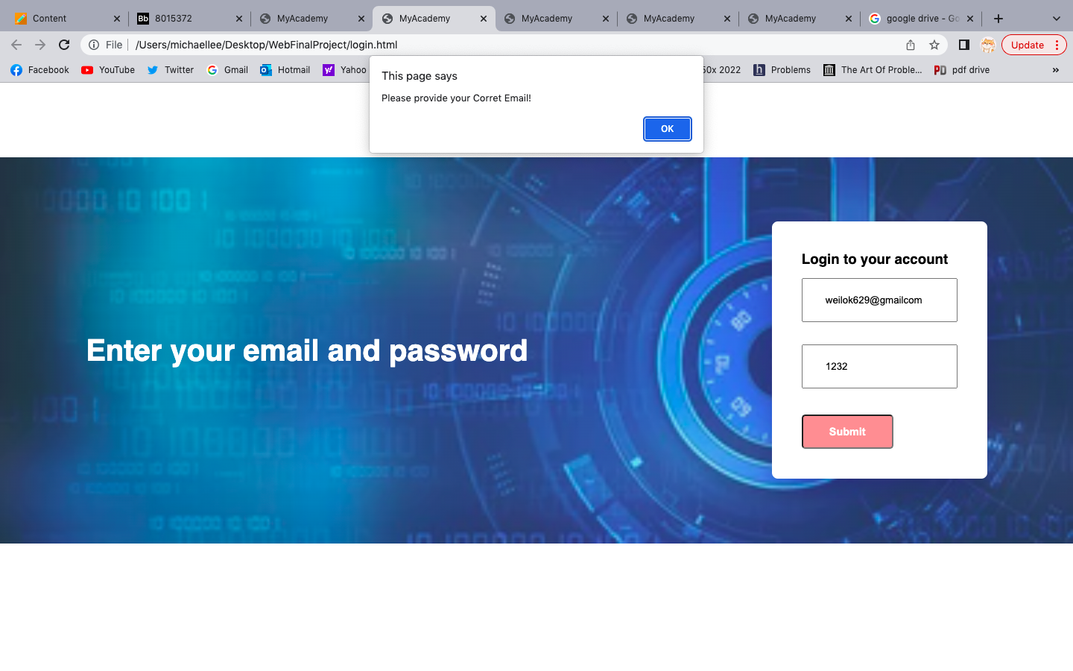

**Empty inputs**

**Didn’t provide email address**

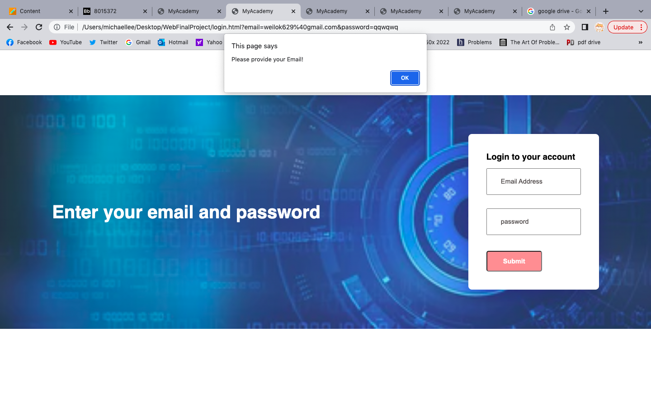

**Didn’t provide password**

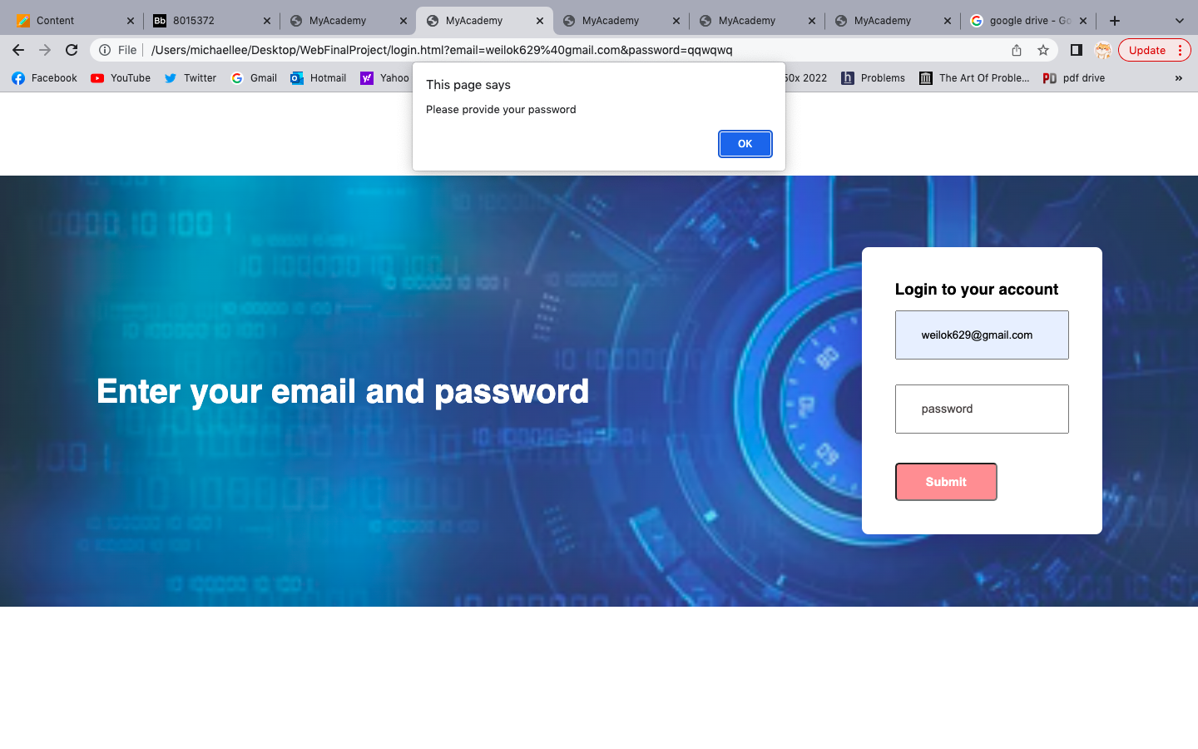

**Contact Function**

The contact function doesn’t allowed empty inputs, it checks the format of email address(like the previous functions) and phone number must be filled in with numerals.

**Success test case**

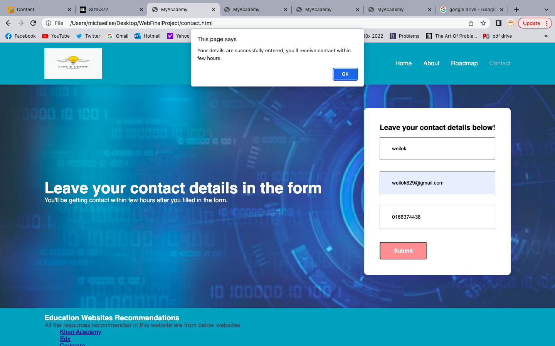

**Presentation video link**

**https://drive.google.com/file/d/1bSDM1dnbTAVslpawity6ExjUS_gA5vW7/view?usp=share_link**